**[All Paths From Source to Target](https://leetcode.com/problems/all-paths-from-source-to-target/description/)**

Given a directed acyclic graph (**DAG**) of n nodes labeled from 0 to n - 1, find all possible paths from node 0 to node n - 1 and return them in **any order**.

The graph is given as follows: graph[i] is a list of all nodes you can visit from node i (i.e., there is a directed edge from node i to node graph[i][j]).

**Example 1:**

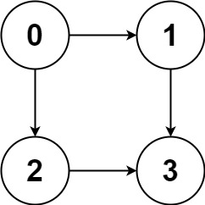

**Input:** graph = [[1,2],[3],[3],[]]

**Output:** [[0,1,3],[0,2,3]]

**Explanation:** There are two paths: 0 -> 1 -> 3 and 0 -> 2 -> 3.

**Example 2:**

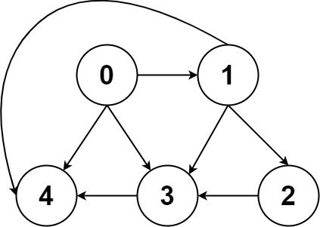

**Input:** graph = [[4,3,1],[3,2,4],[3],[4],[]]

**Output:** [[0,4],[0,3,4],[0,1,3,4],[0,1,2,3,4],[0,1,4]]

**Constraints:**

* n == graph.length
* 2 <= n <= 15
* 0 <= graph[i][j] < n
* graph[i][j] != i (i.e., there will be no self-loops).
* All the elements of graph[i] are **unique**.
* The input graph is **guaranteed** to be a **DAG**.